Final Project of Preety

Online A One **Fashion** Boutique

# **Project Scope**

## **Overview of proposal**

This project is based on online A One Fashion Boutique. There is one secure for admin who can add, delete and access details of the information in the ASP.net project. Admin can also edit, delete and access Sales and Buyer Data. Furthermore, admin can delete viewed message of contacts.

## **Purpose**

Fashion is always changing with unique trends. Especially, the main purpose of my fashion designing website to create latest trend and style with high quality which fits people personality. It is sophisticated who are much busier in their work; they can easily search, select and order. It will also provide free delivery. The Availability of our website 24*7.

## **Goals**

The main aim of this project is to setup a web application of A One fashion Boutique through asp.net. In this application there is admin who can add, edit, delete and check details. Moreover, the main goal of this website is to increase the business and attract more customers.

## **Features**

* Responsive design
* Free delivery & it will take less time for delivery
* Effective navigation
* Webpage speed
* Website needs to have menu tabs so that user can find the services they are looking for
* Easy to access
* Discount tools
* Use simple text and content so customers can easily read

## **Target audience**

This website will give benefits to women and girls. Here every kind of dresses and accessories will be show like western and traditional clothes. It will more helpful for choosing product and find everything.

|  |  |
| --- | --- |
| Deliverable | Description |
| Project Planning | All Details and information about the project |
| Project coding | Testing based on marking coding |
| Implementation Details | Different query implementation for creating deleting the data |
| Documentation | Everything is stored here about the project |

# Browser Support

|  |  |  |
| --- | --- | --- |
| Number | Browser Name | Brower Version that support website |
| 1 | chrome | 72 |
| 2 | Opera | 58 |
| 3 | Firefox | 65 |
| 4 | Safari | 12 |
| 5 | Internet explorer | 11 |

# Domain Names

|  |  |
| --- | --- |
| Number | Domain Name |
| 1 | www.fashionFever.com |
| 2 | www.fashionindustry.in |
| 3 | www.smartlooking.nz |

# Web Hosting Companies Detail

|  |  |  |  |  |  |  |
| --- | --- | --- | --- | --- | --- | --- |
| Number | Web Hosting Company Name | Review | Price | Support | Speed | Bandwidth |
| 1 | Blue host | Best test for speed uptime, support value | $3.95 | 10/10 | 627ms | Unlimited |
| 2 | Site Ground | Best all-round word press host | $4.95 | 9/10 | 611ms | 10GB |
| 3 | A2 HOSTING | Currently host dozens of websites | $3.92 | 8/10 | 812ms | Unlimited |

# **Page Content Details**

Home Page: - A home page is generally the main page a visitor navigating to a website from a web search engine will see, and it may also serve a landing page to empress customers. The home page is used to facilitate navigation to other pages on the site by proving links to recent articles and pages, and possible a search box.

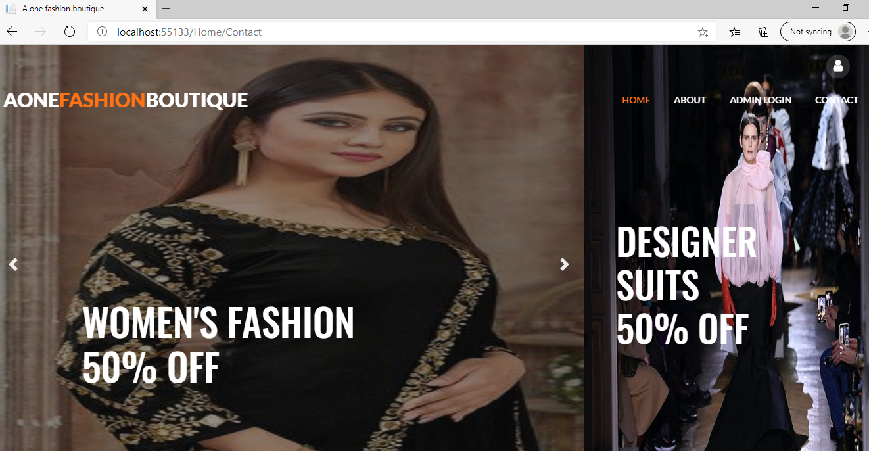

Sale: - This is imaging page for sale. In this website you will see different kind of sales on dissimilar products. Sales will like shop by price and shop by discount.

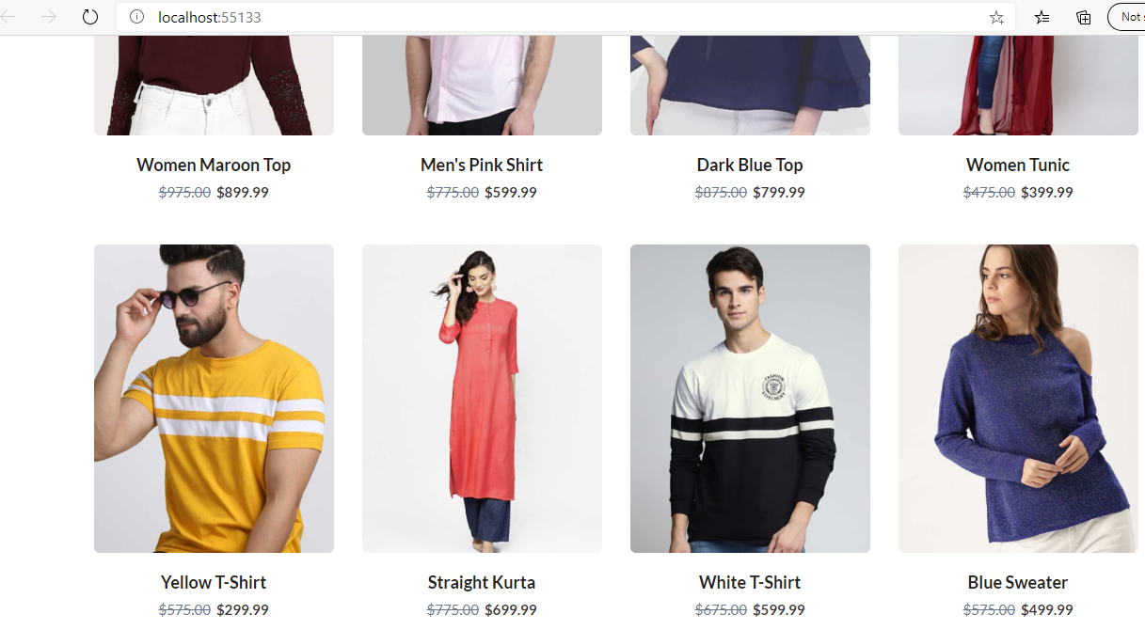

Contact us: - when customers will click this button, they can easily contact me, and they can get information anything. If they have any problem, they can ask any question.

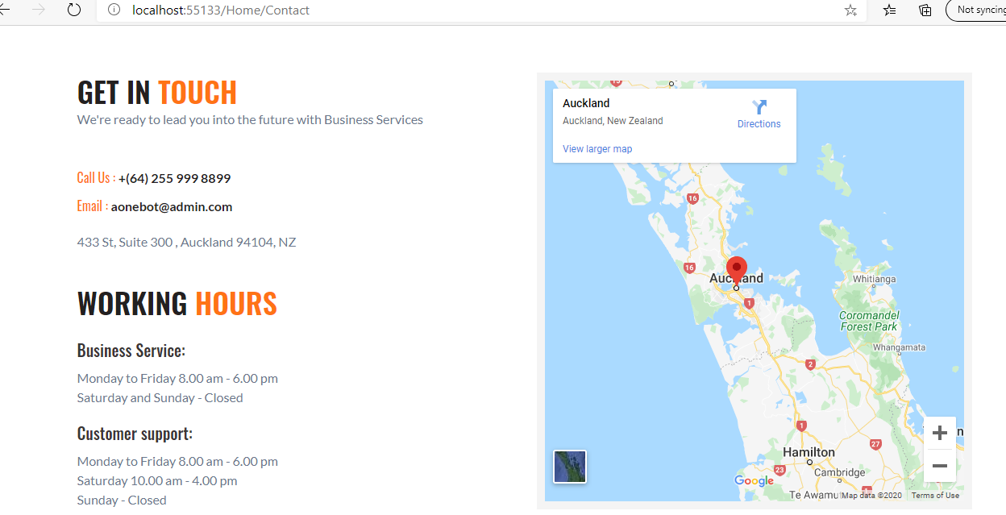

About us: **-** This page about A one fashion boutique deeply dedicated to the ethical and human production of everyone our piece. We will tolerate nothing less. Every supplier signs a binding letter of agreement to heed to the highest production Standards and we enforce those standards.

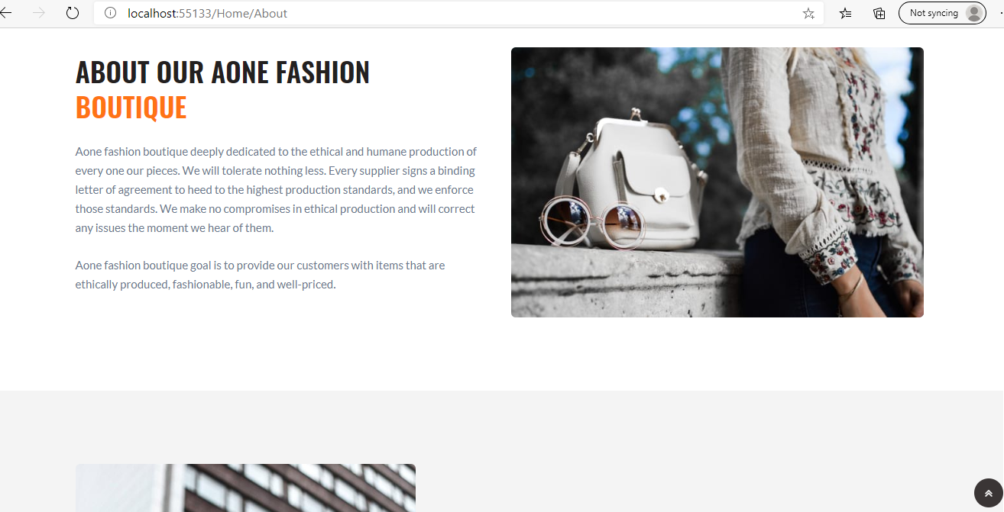

Login: -This is very important page to visit on next page. When client will press the login button, they need to fill email in email box and password in password box. After filling detail, they will click login button, then they will reach on that page where all things will appear.

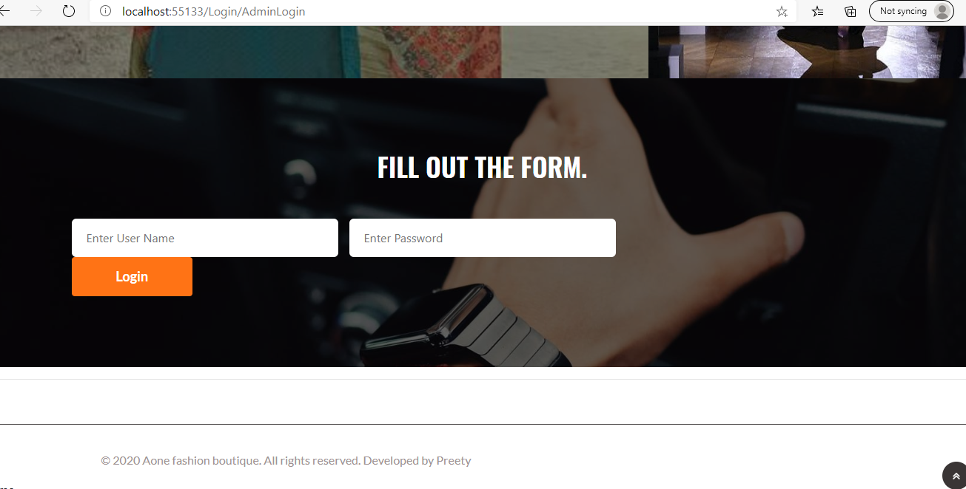

Locate us: - It page will help you for visiting my website. If anyone cannot find the company location, there is an option locates us where we can upload the current location of company, so customer can easily find the location.



# 